(Insert Client Name Here) Interview Brief

Interviewees: | (insert name of person or persons being interviewed)
Media Outlet/Reporter: | Tampa Bay Business Journal  Luke Torrance
When and Where: | Day, Month, Day, Year  XX:XX a.m. EDT – interview prep  XX:XX a.m. EDT – interview with reporter  Zoom link to be provided via email
Interview Topic:

Reporter Info:  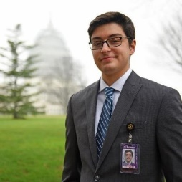 | Luke Torrance is the Money reporter for the Tampa Bay Business Journal, where he writes about banks and public companies. He previously worked as the digital producer for the Pittsburgh Business Times, where he was responsible for morning, afternoon and breaking news emails sent to subscribers, promoting stories on social media, and ensuring that the site hits goals for visits and page views. He also covered higher education, sports business and transportation news in the Pittsburgh region.  Prior to joining ACBJ, he worked as a reporter covering Port Washington and the Nassau County government on Long Island for the Island Now newspapers. In 2017, he graduated with a major in journalism and a minor in political science at Ohio University in Athens, Ohio.  For most of 2016, Torrance covered news and politics in Washington D.C. for the Scripps Howard Foundation Wire and The Hill. On assignment, he often took his own photos and video for his stories.
Outlet Info: | The Tampa Bay Business Journal covers the latest breaking business news in the Tampa area, updated throughout the day via its daily digital content. It also has a weekly print edition that is distributed on Thursdays. It is one of 40 weekly business journals owned by American City Business Journals.
Seacoast Overarching Message: | - Key Message 1  - Key Message 2  - Key Message 3
Seacoast Supporting Messaging: | Questions to Anticipate  Q1.  A1.  Q2.  A2.  Q3.  A3.  Q4.  A4.  Q5.  A5.  Q6:  A6:
# # #

